Table of Contents

Topic of the site

HAMK RESTAURANT

Target Audience

Audience from all ages.

Website look and feel

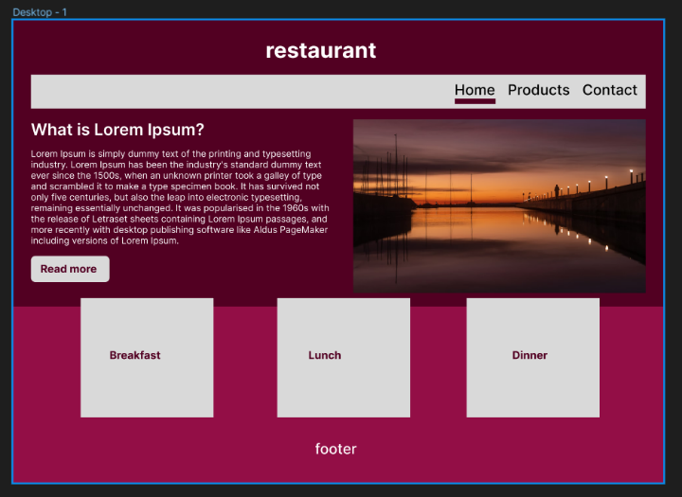 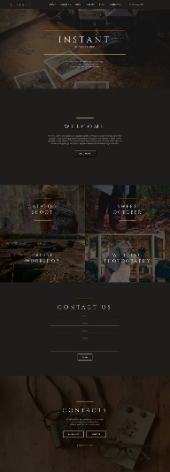

https://fi.pinterest.com/pin/493214596697618147/

Website will have a dark color Home page. And three other menu pages. Images. Text. Footer etc…

Color Palette

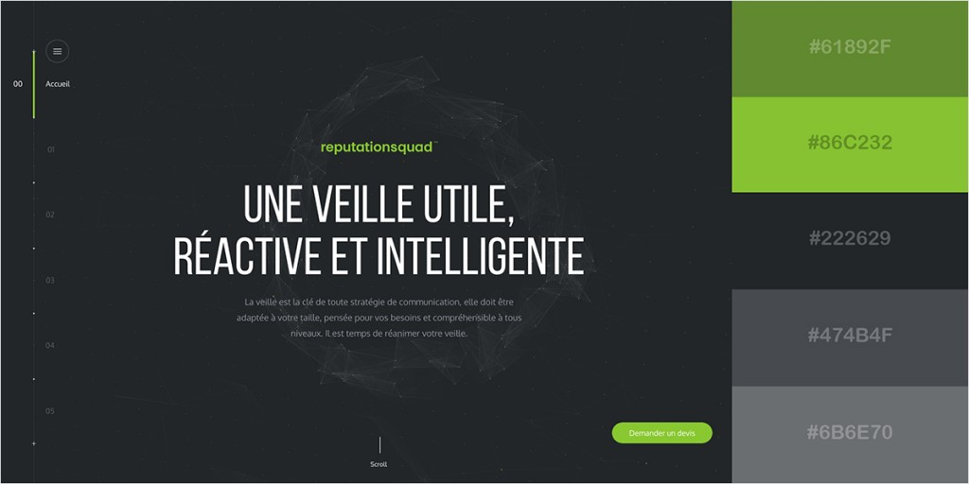

Teamwork Practices

At campus, online, Github